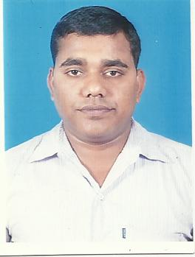
CURRICULUM VITAE

NANDA DULAL PATRA

E-mail  nanda.patra@gmail.com  Phone Nos. :  7749994397  Address for Correspondence:  CH-98,Chandrasekhar Pur,  Bhubaneswar -751024  Personal Details:  Date of Birth : 22nd Jan 1986  Gender : Male  Religion : Hindu  Nationality : Indian  Marital Status : Married  PREVIOUS COMPANY -1  PREVIOUS COMPANY -1  Educational Data:  HOBBIES / INTEREST:  PERSONAL SKILLS: | Career Objective  - Intend to build a career with leading corporate at hi-tech environment with committed and dedicated people, which will help me to explore myself fully and realize my potential so that I can utilized my skill in corporate sector or related industry that offers personal growth & I would like to work in challenging environment which enhances creative thinking, promoter decision making and job satisfaction.  Work Experience  PRESENT COMPANY  Working as HR RECRUITER in INFORAS TECHNOLOGIES SOLUTIONS, BHUBANESWAR from May 2015 to Till Now.  Responsibility:  ► Responsible for sourcing from different source, as per client requirement & Campus process.  ► Interview co-ordination at client place.  ► Employee Co-ordinate.  ► Worked in IT (Java, .Net, Hardware Networking), Backend, Sales, Accounts, Admin, Retail, Call Centre Executive positions.  ► Worked mostly on junior & mid level assignments.  ► On boarding for internal employees.  ► Customer Satisfaction Service.  Working as Business Development Officer in STAR INFRASTRUCTURE & TECHNOLOGY SERVICES, BHUBANESWAR from Jan 2010 to April 2015.  Responsibility:  ► Achieve Business Target  ► Daily tracking of DST activity  ► Weekly planning to achieve the monthly target  ► Risk For collection Amount  Working as DATA CARD FOS in RELIANCE COMMUNICATION, FORTUNE TOWER, BHUBANESWAR from March 2008 to Oct-2009.  Responsibility:  - Daily Customer Visit.  - Prospect Generate  - Weekly planning to achieve the monthly target.  - Star(*) Of The Day Winner 4 times (From India Level sales team).  - Star(*) of the Month winner 5 times (From India Level sales Team)  - MBA in HR from NIBM Chennai in 2015,  - BBA From Barkatullah University, Bhopal in 2008.  - +2 from WB Board of Higher Secondary in 2003.  - 10th from WB Board of Secondary in 2001.  - Listening to music & Playing with computer GAME  Result oriented, Bold, Effective, Team spirit, Co-operative , Positive attitude and  Hardworking.  Declaration  I do hereby declare that all the information furnished above is true to the best of my knowledge and belief.  Date-:  Place-Bhubaneswar NANDA DULAL PATRA

